Kingsmire, Quick and Dirty

Region
- The nation/region is Waldland. This is the scope of the central thematic tension (Civilization vs Nature)
- Kingsmire is a swampy subregion in Waldland, this is the scope of the central narrative tension (west-lake/Humans vs east-lake/Boggits)

Central Tension
- The old duke was happy to let the boggits be, but the new duke wants to make his mark in history. His goal is to claim the dwarf ruins in the hills to the east, beyond the swamp. But the boggits are in his way.
- The boggits also patrol the waters of Lake Kingsmire around its outlet to the Major River. Currently, to ship stuff via water, the city has to take a detour along the river through the monasteries. The duke would love to claim the whole lake, making shipping much easier. (think of the money!)
- The boggits have their own new leader: ordained by their deity, the chosen one, their new warleader (with psionic powers)!

Ancestries
- Humans (and polder) dominate the political hegemony of west lake.
- Boggits dominate east lake.
- Dwarves interested in joining (or hindering?) the human expeditions to the eastern ruins are in town.
- Wode elves from the north trade with boggits
- Ratfolk also live in the swamp and the civilizations, acting as liaisons, or more like opportunists, between west and east.
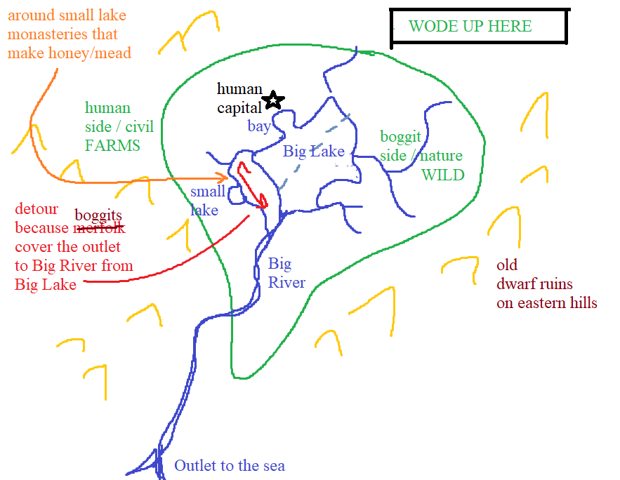

Locations
- West of Kingsmire lake, the land is wet, but farmable. The humans have tamed the swamp and made it work for them. This is Civilization! If the humans were all to get up and leave, their scars would remain for decades, at least.
- East of Kingsmire lake, the boggits live among the undisturbed swamp. If the boggits were to up and leave, any evidence of their lives would disappear to the swamp in days, if not hours. This is Nature!
- Lining the detour river south-west of the lake, and especially around the small lake it passes through, there are many human monasteries! Lots of these monasteries have apiaries (bee farming) and make mead. It’s a major export of the region!
- In the ancient past, the dwarves had ruins all over this region (which was a lake surrounded by farmland, not a swamp! At the time). They had big structures that coursed with electricity. And they had powered systems that automatically drained areas and irrigated areas, etc. But the dwarves left (or were killed? Don’t know) and their structures all sank into the lake, the region becoming a swamp without their tending of the land. Those structures are still in the swamp, and their mechanisms still function, as do the golems that protect them.

More Details
- The boggits ranch/farm bugs! The bugs make hives, similar to how the human monasteries have apiaries! But, while the boggit’s bugs are happy to make hives in particular structures the boggits make, they also love to make hives in… FLESH!
  - Out in the swamp, if there are corpses unattended, the bugs will make hives in the corpse, and their activity will cause the corpse to MOVE! And protect the hive!
  - These hive-undead are a major issue, and are oddly… proactive! Hordes of hive husks will attack human towns especially on the northern border of the lake, where west meets east, where farmland meets swamp.
  - The honey produced from boggit bugs is a natural and powerful hallucinogenic! The boggits use it for rituals in their culture, but the humans use it for fun! Of course, the humans don’t make it themselves… but the ratfolk are happy to smuggle the honey into town and sell it for tons of cash!

